Tel: 661-484-3938 Fax: 661-829-6413 E-mail: info@anastasistoursusa.com
www.anastasistoursusa.com
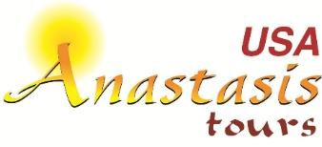
Join Fr. Joshy Mathew, in the Pilgrimage to Portugal- Spain- France
16 Days 14 Nights from September 12-27 of 2024

Sep 12: USA – LISBON (PORTUGAL)

Sep 13: LISBON – FATIMA.
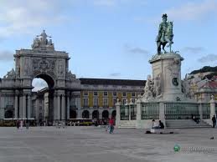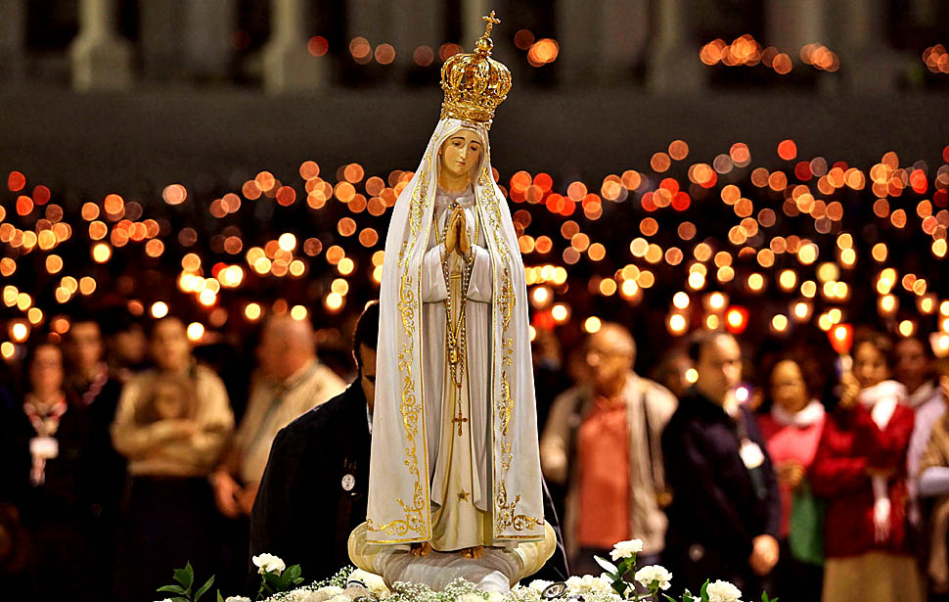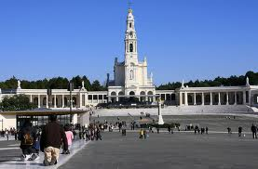
Arrive at Lisbon Airport. Meet your tour guide and transfer to Fatima. Have Dinner at the hotel and overnight. You may join the Candlelight procession after dinner
Sep 14: FATIMA- NAZARE-FATIMA
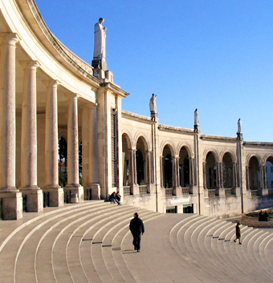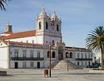
Enjoy a buffet breakfast at the hotel. Free time to participate in the Holly Mass at the main Church. A guided tour will include the Capelinha (Apparition Chapel), the Basilica, which contains the Tombs of the 3 visionaries, Bl. Jacinta, Bl. Francisco and Sr. Lucia, their homes, and important sites where the apparitions of the Angel and Our Lady took place. In the after noon, travel to a small town of Nazare and visit the shrine dedicated to Virgin Mary. Return to hotel to have dinner and overnight.
Sep15: FATIMA – CACERES – MADRID.

Breakfast and leave towards the middle age city of Caceres in the Spanish Autonomous Community of Extremadura. A small break for rest and continue to Madrid, the capital of Spain. Have Dinner and overnight.

Sep16: MADRID – TOLEDO – MADRID.

Breakfast. Today we’ll take an excursion to Toledo, one of the oldest cities in Spain. It was the capital from the 6th. until the 8th. century. It is known as the Imperial City. Famous for its Cathedral and Castle. It has been also the city that reunited three cultures and religions: Christians, Muslims and Jews. It is also the birthplace of historical figures and especially the famous Spanish painter El Greco. Return to the hotel. Have Dinner and overnight.

Sep 17: MADRID – ZARAGOZA.
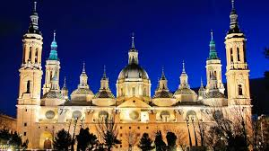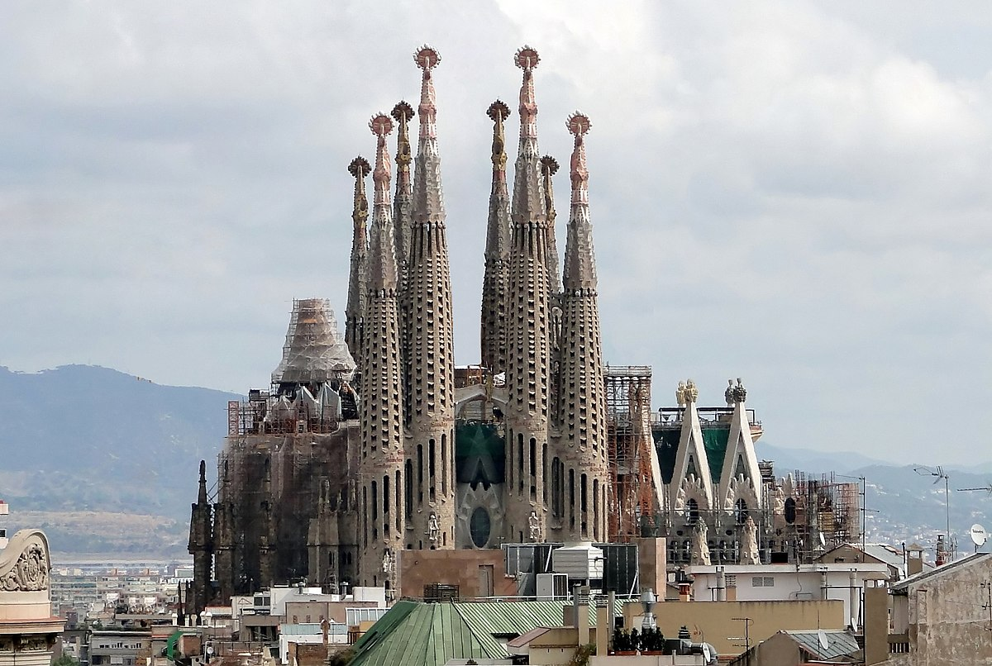
Breakfast at the hotel. Morning will be dedicated for a panoramic city tour of the Spanish Capital: Plaza de España, Orient Palace, the Opera, Plaza Mayor, the Prado Museum, the Santiago Bernabeu Stadium….etc. In the afternoon, drive to Zaragoza, the capital of the Province of Aragon. Have Dinner and overnight at the hotel.

Sep 18: ZARAGOZA.
Breakfast at the hotel. Start with a visit to the Cathedral of our Lady of the Pillar, considered as the oldest Sanctuary in Europe dedicated to Virgin Mary and linked to St. James the Great who spread Christianity in the Iberian Peninsula. Walk through the ancient quarter of this beautiful city. Have Dinner and overnight.

Sep 19: ZARAGOZA – MONASTERY OF MONTSERRAT – BARCELONA.
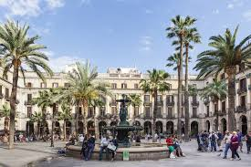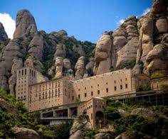
Breakfast at the hotel. Drive towards the east to Barcelona and stop at the famous Abbey of Montserrat which is a Benedictine abbey located on the mountain of Montserrat. It is notable for enshrining the image of the Virgin of Montserrat. The monastery was founded in the 11th century and rebuilt between 19th and 20th century, and still functions to this day, with over 70 monks. Arrive to your hotel in Barcelona. Have Dinner and overnight.

Sep 20: BARCELONA.

Breakfast at the hotel, visit the Basilica of the Holy Family, which is a large unfinished Roman Catholic church in Barcelona, designed by Catalan architect Antoni Gaudí (1852–1926). Gaudí's work on the building is part of a UNESCO World Heritage Site, and in November 2010 Pope Benedict XVI consecrated and proclaimed it a minor basilica, as distinct from a cathedral, which must be the seat of a bishop. Then we’ll do a panoramic tour of the capital of the Province of Cataluña passing by its major monuments. Have Dinner and overnight at the hotel.

Sep 21: BARCELONA – LOURDES (FRANCE).
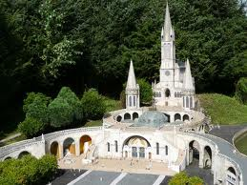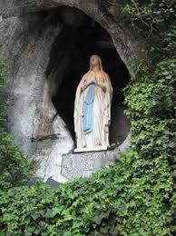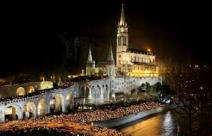
Breakfast at your hotel. Depart to Lourdes. Arrive to Lourdes; enjoy a panoramic drive of Lourdes. You may participation in the candle light procession after dinner. Return to hotel over night.

Sep 22: LOURDES

After breakfast, take a walking tour of Lourdes, a shrine that receives 5Million pilgrims from all over the world every year. The spirituality of the Place touches everyone, visit the shrine of Our Lady, the Cave of the Apparititions and a possibility to take a bath in the water of the River. Rest of the day at leisure for personal prayer and other activity. Dinner and over night at your hotel.

Sep 23: LOURDES- BURGOS.

Breakfast at the hotel. We will arrive before lunch at Burgos. Situated in the Pilgrim's Road to Santiago de Compostela, still preserves important vestiges of its medieval splendour. The city, which was the capital of the unified kingdom of Castilla-Leon for five centuries, boasts a masterpiece of Spanish Gothic architecture: the cathedral of Burgos, declared World Heritage. Aside from a visit to the historic quarter, you can take a quite interesting walk along the banks of the Duero and Arlanza rivers.

Sept 24: BURGOS-SALAMANCA

After breakfast, departure to Salamanca. It’ s known as the city of thought and knowledge, but here you will also find art and beauty. Its old town has the UNESCO World Heritage designation, and is home to a magnificent ensemble of monuments, with outstanding examples of different architectural styles: Romanesque, Gothic, Baroque, and Plateresque... The University, besides being one of Spain's oldest, is also one of the country's best examples of Renaissance architecture.

Sept. 25: SALAMANCA-LISBOA

Breakfast at the hotel. Departure to Lisboa. We will make a stop at the very beautiful village of Ciudad Rodrigo. After lunch we will arrive to Lisboa. And enjoy a panoramic drive through the new and old Part of Lisbon including Belem Tower, Monument of the discoveries, and the birthplace of the beloved St. Anthony. Have dinner and over night at your hotel.

Sep 26: LISBON

Breakfast at hotel. Full day for visiting Lisbon with a walking guide tour including the entrance of the very beatiful Jeronimo’s Monatery. Wonder at the Torre de Belém. Ride Tram 28 to the old part of the city. Get lost in the Alfama District.

Sept. 27: LISBON-USA

Breakfast at the hotel. In due time, transfer to Lisbon International Airport to board your flight back to the USA.

