Tel: 661-484-3938 Fax: 661-829-6413 E-mail: info@anastasitoursusa.com
www.anastasistoursusa.com

JOIN DEACON JERRY GIGER IN A PILGRIMAGE TO THE MARIAN SHRINES FROM FATIMA TO BARCELONA
A 12 DAYS 10 NIGHTS PILGRIMAGE FROM SEPTEMBER 16-27 OF 2024
ST. PATRICK CATHOLIC CHURCH, CANBY, OR USA
SEP.16: USA – LISBON (Portugal)

SEP.17: LISBON – FATIMA
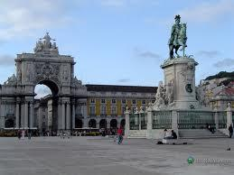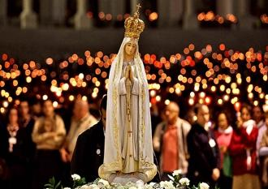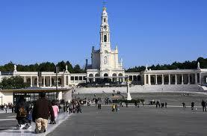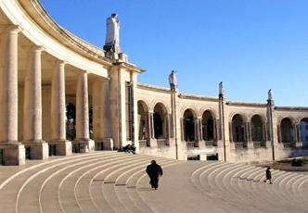
On arrival, if time allows, enjoy a panoramic drive through the new and old parts of Lisbon including Belem Tower, Monument of the Discoveries, Jeronimo's Monastery, and the birthplace of the beloved St. Anthony. Continue to Fatima, one of the most famous Marian shrines in the world for a visit to the Sanctuary. Check-in to your hotel close to the shrine area. You may join the Candlelight Procession after dinner.
SEP.18: FATIMA – SANTIAGO DE COMPOSTELA (SPAIN)

Enjoy a buffet breakfast at the hotel. A guided tour will include the Capelinha (Apparition Chapel), the Basilica which contains the tombs of the 3 visionaries, Bl. Jacinta, Bl. Francisco and Sr. Lucia, their homes, and important sites where the apparitions of the Angel and Our Lady took place. In the afternoon, leave for Santiago de Compostela (Spain)
SEP.19: SANTIAGO DE COMPOSTELA – BURGOS
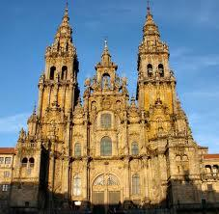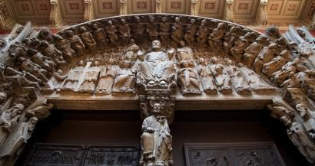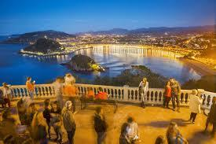
Breakfast at the hotel. Visit the Plaza del Obradeiro which has important monuments, including the Cathedral of St. James. Its current Baroque facade gives way to a Romanesque doorway from the original building, the Portico de Gloria, created by master Mateo in the 12th century, Archbishop's Palace and Rajoy Palace. Walk the oldest streets of the city which date from the 12th century - Ruas Franco, Vilar and Nova. Continue to the city of Burgos. Dinner and overnight.

SEP. 20: BURGOS – SAN SEBATIAN – LOURDES (France)
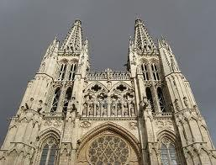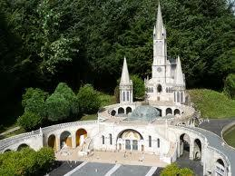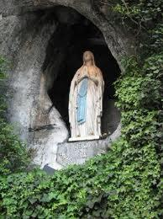
Breakfast. Visit the Cathedral of Burgos, built in 1221 AD and dedicated to Virgin Mary. Then leave for San Sebastian, a beautiful city on the Bay of Biscay for an orientation tour and a stop at the famous Playa de la Concha. Continue to the French borders onto Lourdes. Check-in at your hotel. After dinner, participation in the Torch Procession.
SEP.21: LOURDES - ZARAGOZA
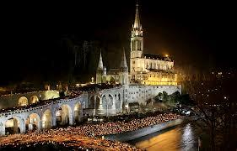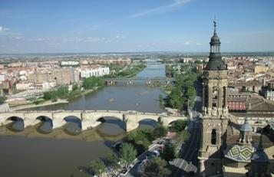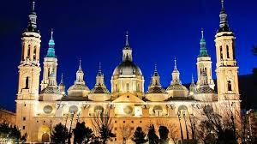
After breakfast, take a walking tour of Lourdes, a shrine that receives 5 million pilgrims from all over the world every year. The spirituality of the place touches everyone. Visit the Shrine of Our Lady, the Cave of the Apparitions, and a possibility to take a bath in the waters of the river. In the afternoon, leave through the Pyrinees Mountain to Zaragoza. Dinner and overnight.
SEP.22: ZARAGOZA – MADRID

Breakfast at the hotel and start a guided tour of the Basilica of Our Lady of the Pillar, one of the oldest churches in Spain, built following the request of Virgin Mary to the Apostle James who received from Her the Pillar as the foundation of this first church. In the afternoon, continue to Madrid. Dinner and overnight.

SEP.23: MADRID – TOLEDO – MADRID
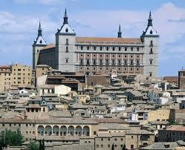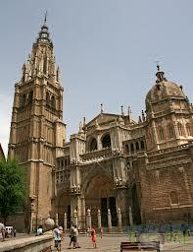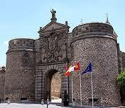
Breakfast at the hotel. Leave to the city of Toledo, the first capital of Spain. Walk through its medieval and picturesque streets to reach the Castle that dominates the city. Visit also the famous Cathedral of Toledo which contains numerous valuable treasures from the different periods- Return to Madrid. Dinner and overnight.

SEP.24: MADRID – VALENCIA
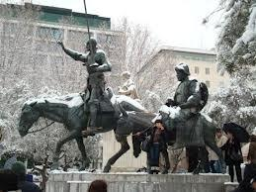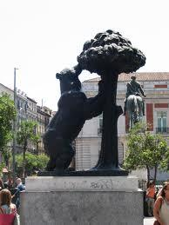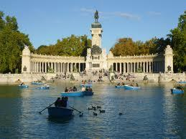
Breakfast at the hotel. We will start a panoramic city tour of the capital of Spain, passing through its major monuments: Plaza de España, , the Orient Palace, Puerta del Sol, Parque del Retiro….etc. Then drive to southeastern to Valencia, the third largest city of Spain, situated on the Mediterranean Sea, famous for its orange and rice plantations. Dinner and overnight.

SEP.25: VALENCIA – MONTSERRAT – BARCELONA

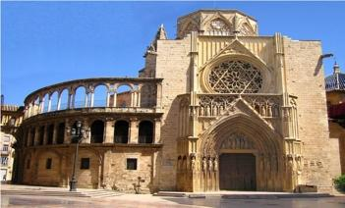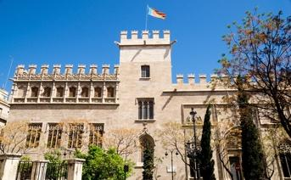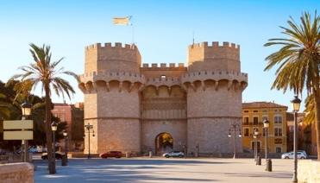
Breakfast at the hotel. We will enjoy a city tour of this beautiful city starting with the Cathedral, known as well by Our Lady of the Assumption. Continue to the building of the Generalitat, the central house of the government, then to La Lonja Building and the Central Marketplace, known as the Silk Market. We will end up in the famous Towers of Serrano which were the main entrance gate to the city in the middle age period.
Leave to the famous Abbey of Montserrat which is a Benedictine abbey located on the mountain of Montserrat. It is notable for enshrining the image of the Virgin of Montserrat. The monastery was founded in the 11th century and rebuilt between 19th and 20th centuries, and still functions to this day, with over 70 monks. Arrive to Barcelona, dinner and overnight.
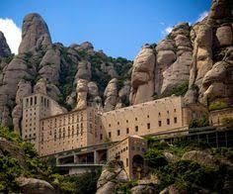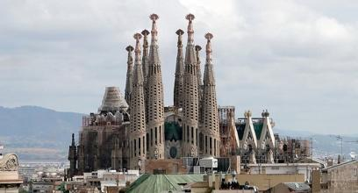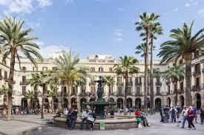

SEP.26: BARCELONA

Breakfast at the hotel. Visit the Basilica of the Holy Family, which is a large unfinished Roman Catholic church in Barcelona, designed by Catalan architect Antoni Gaudí (1852–1926). Gaudí's work on the building is part of a UNESCO World Heritage Site, and in November 2010 Pope Benedict XVI consecrated it and proclaimed it a minor basilica, as distinct from a cathedral, which must be the seat of a bishop. In the afternoon, an orientation tour through its major streets and monuments. Dinner and overnight at the hotel.

SEP.27: BARCELONA – USA
Breakfast at the hotel. In due time transfer to EL PRAT airport to board your flight back to the USA.

